Task for: Thursday, February 2, 2023

1. Design the bellow table:

|  |  |  |  |  |  |  |  |
| --- | --- | --- | --- | --- | --- | --- | --- |
| Customer_ID | First_Name | Last_Name | E -mail | Phone | Age | Job_Title | Gender |

1. Design Another table That with name Orders

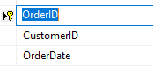

**Last order:**

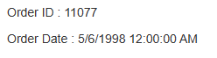

|  |  |  |  |  |  |  |  |
| --- | --- | --- | --- | --- | --- | --- | --- |
| ID | First Name | Last Name | E -mail | Phone | Age | Job Title | Gender |
| 1 | Ali | Ahmad | [Ali@gmail.com](mailto:Ali@gmail.com) | 078 | 20 | Developer | Male |
| 2 | Sami | Odai | [Sami@gmail.com](mailto:Sami@gmail.com) | 078 | 22 | Designer | Male |

Note: use Partial View concept